**ITS290F Human Computer Interaction & User Experience Design**

**Lab 7. UI Design (Part 2)**

What you’ll learn in this lab:

* Applying UI design guidelines and principles
* Identifying user error

**1. Readings**

Suggested reference readings

1. The Eight Golden Rules of Interface Design

<http://www.cs.umd.edu/~ben/goldenrules.html>

1. User Interface Design Guidelines: 10 Rules of Thumb

<https://www.interaction-design.org/literature/article/user-interface-design-guidelines-10-rules-of-thumb>

**2. Lab Exercises**

On your own, follow the instructions to finish the exercises. For short text questions, put down your answers in the answer textboxes. For coding exercises, you may edit your code with any text editor. Put your solution code in the solution textboxes when finished.

In the lecture, you have learned different user interface design guidelines. These guidelines are useful for us to design good UIs for different applications. For the lab exercises, we will use the guidelines to evaluate existing UIs and suggest for improvement.

**Exercise 1**

|  |
| --- |
| 1. What is system status? Describe the UI design guideline about *visibility of system status*. |
| Your answer…  System status is the status of system operations  Users should always be informed of system operations with easy to understand and highly visible status displayed on the screen within a reasonable amount of time |

The following is an UI of a personal to-do list that allows a user to add his to-do items, mark the items done, and keep track of the remaining items.

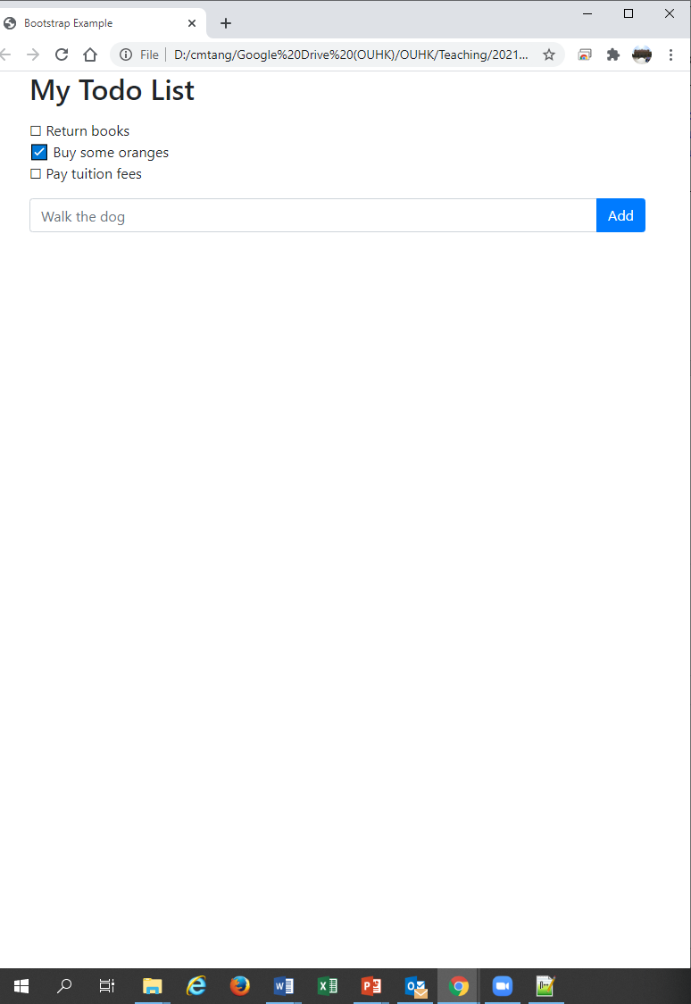

Download **T07Ex01.html** file of the above personal to-do list. Open the file with a web browser and try it out.

|  |
| --- |
| 1. Suggest one most useful system status that can be added to the UI. |
| Your answer…  The number of not yet finished thing(s) |

Assume you want to add a badge that shows the status of the number of outstanding to-do items. Follow the instructions below to add the badge:

1. Open **T07Ex01.html** file with a text editor.
2. Add a badge with default label “0” next to the “My Todo List” header. The statement has been written for you. Insert the following statement after the <H2 …> heading:

<span id="systemStatus" class="badge badge-danger align-top">0</span>

1. After making the update, you should see a badge is appended to the heading like the follows:  
   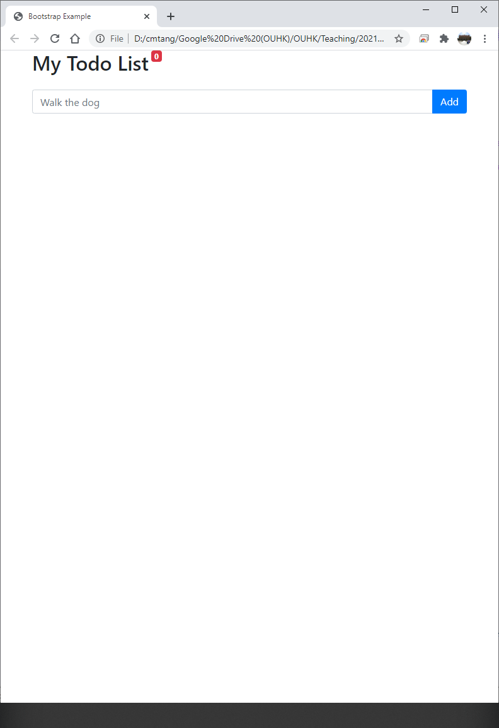
2. However, the badge is not yet functional. Add the following statements to the end of the <script> section to make it responsive to the event of the checkboxes:

document.getElementById("todo").onHTMLUpdate = updateSystemStatus();

function updateSystemStatus() {

let todo = document.getElementById("todo").getElementsByTagName("li");

let n = 0;

for (var i=0; i < todo.length; i++) {

if (!todo[i].classList.contains("checked")) {

n++;

}

}

document.getElementById("systemStatus").innerHTML = n;

}

1. Save the file and try it on a web browser.

|  |
| --- |
| 1. Is the badge now functional? (yes / no) |
| Your answer…  yes |

**Exercise 2**

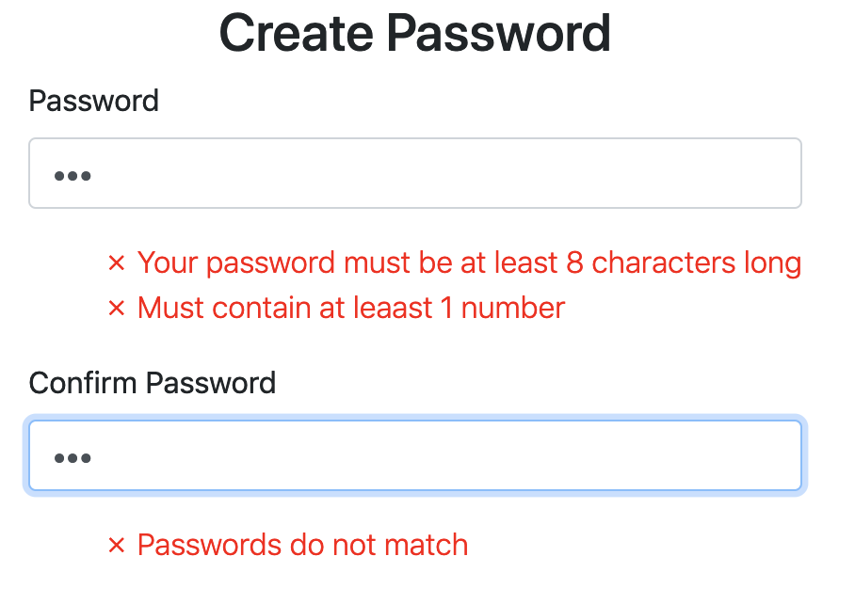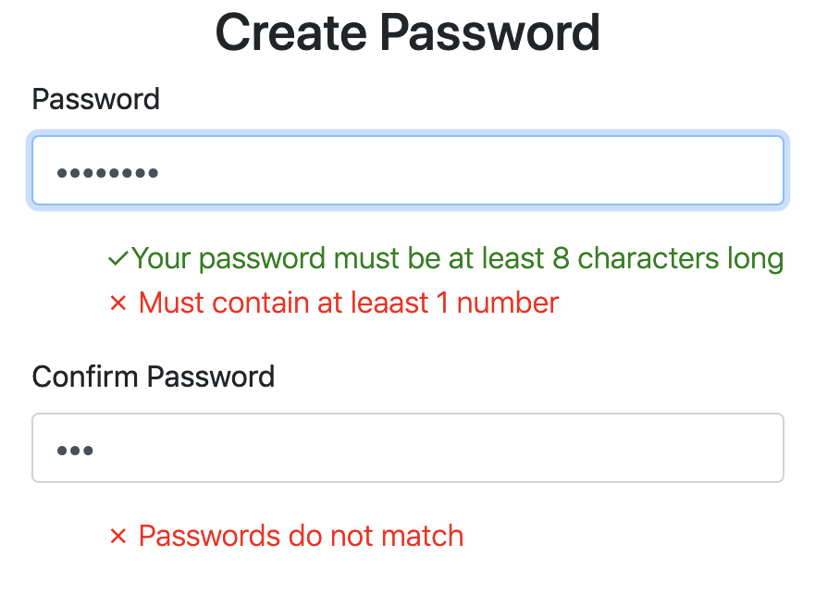

The above application allows users to create passwords, where the passwords need to satisfy the following requirements:

1. Length of password must be at least 8 characters long.
2. Passwords must contain at least 1 numeric character.

|  |
| --- |
| 1. Describe how the above UI achieve the principle “Offer information feedback”. |
| Your answer…  For every input, there will be an interface feedback. Tells the user whether there are any problems, and also can help user know their changes explicitly. |

|  |
| --- |
| 1. Describe how the above UI achieve the principle “Help users recognize, diagnose, and recover from errors”. |
| Your answer…  1. There are very detailed description to help the user find what type(s) of error(s) they made.  2. As the user make the error, the corresponding notice will be red, which helps the user find where they make the error. |

Download **T07Ex02.html** file of the above create passwords application. Open the file with a web browser and try it out.

You may find that the application has some anomalies in showing the password requirements hints. It is identified that the page has three program bugs in each of the three functions in the <script> section. Fix the bugs to make the webpage functional.

|  |
| --- |
| 1. List the bug fixed statement in the validatePassword() function. |
| if (document.getElementById("password1").value.length >= 8) { |

*The first bug has been fixed for you!*

|  |
| --- |
| 1. List the bug fixed statement in the checkSamePassword() function. |
| Your bug-fix statement...    if (document.getElementById("password1").value === document.getElementById("password2").value) {  showConfirmPasswordHint("yes")  }  else {  showConfirmPasswordHint("no")  } |

|  |
| --- |
| 1. List the bug fixed statement in the showConfirmPasswordHint() function. |
| Your bug-fix statement...  function showConfirmPasswordHint(status) {  if (status == "no") {  document.getElementById("confirmPasswordHint").classList.remove("d-none");  document.getElementById("confirmPasswordHint").classList.add("d-block");  } else {  document.getElementById("confirmPasswordHint").classList.remove("d-block");  document.getElementById("confirmPasswordHint").classList.add("d-none");  }  } |

|  |
| --- |
| 1. Have you fixed all three bugs? |
| Your answer…  Yes |

**Submission**

You will get 0 to 3% of OCAS score upon completing the lab exercises.

1. Put your solution code inside the answer boxes and save the file.
2. Upload this file via the corresponding submission link on OLE.

**Note:**

1. The submission deadline is 23:59 of the forthcoming Thursday. The submission link will be closed after the deadline.
2. We mainly focus on the correctness and quality when grading your work.
3. Make sure you submitted a correct file. You can resubmit your work before the deadline.

1. DO NOT modify the layout and format of this document, and DO NOT save it as other file formats, i.e., PDF. Your work will be extracted using an automated document parsing tools for grading.

--- End ---